VELMURUGAN. A
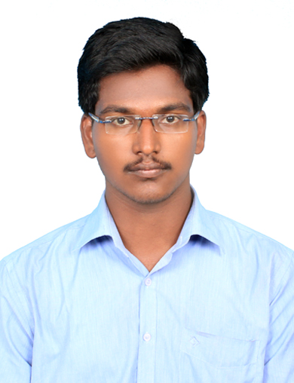
No: 37/19 South Fort Street,
Vriddhachalam – 606 001,
Cuddalore District,
Tamil Nadu,
India.
* velu1307@gmail.com
' +91- 7373373420
----------------------------------------------------------------------------------------------------------------
OBJECTIVE
To utilize my skills and abilities in an industry that offers professional growth, research and development while being innovative and flexible.

EDUCATIONAL QUALIFICATION

Qualification | Institution | Board/  University | CGPA/  Percentage | Year of passing
PhD | Indian Institute of Technology Madras | IIT Madras | 7.59 | Pursuing
M.E  (CONSTRUCTION ENGINEERING AND MANAGEMENT) | College of Engineering, Guindy | Anna University | 8.53 | 2016
B.Tech  (CIVIL ENGINEERING) | Kalasalingam University | KalasalingamUniversity | 8.04  (CGPA) | 2013
H.S.C | Fatima Matriculation Higher Secondary School | State Board | 79.08 | 2009
S.S.C | Fatima Matriculation Higher Secondary School | Matriculation | 82.82 | 2007

PROJECTS
-"Study on Thermal Performance of Exfoliated Vermiculite Block Masonry" (Chennai, November 2015)
-"Studies on Strength and Durability properties of Cement Mortar using Marble Powder as a partial replacement of cement (Srivilliputtur, May 2013)

SKILL SETS
- AutoCAD, Primavera, MS Project

EXPERIENCE
- Lecturer in IFET College of Engineering, Villupuram (From Aug 2013 to May 2014)
- Teaching Assistant in Kalasalingam University (From July 2016 to Nov 2016)

AREA OF INTEREST
- Sustainability
- Life Cycle Assessment
- Occupational Health Prevention
- Energy Efficient building design
- Equipment Management
- Cost Management

EXTRA CURRICULAR/CO-CURRICULAR ACTIVITIES

ACTIVITY/EVENT | YEAR | LEVEL | ACHIEVEMENT/RESPONSIBILITY
National Service Scheme Programme | 2011 | Regional | Special camping programme on the theme “HEALTHY YOUTH FOR HEALTHY INDIA ”
Nature Club | 2009-2013 | College | Participant
Sports Day Contest | 2012 | Intra- College | Won Second prize in chess

ADDITIONAL INFORMATION
-In-plant Training for a period of 28 days in TNPHC, Chennai (July 2015)
-In-plant Training for a period of 28 days in PWD, Sivagangai (Dec 2011)
-Undergone 4 additional courses and 2 free elective courses in Kalasalingam University (From Nov 2011-May 2013)
-Active member in Indian Concrete Institute.
PERSONAL PROFILE
Date of Birth : 13-07-1991
Gender : Male
Nationality : Indian
Languages Known : Tamil, English

I hereby declare that the details furnished above are true to the best of my knowledge and belief.

Velmurugan.A

